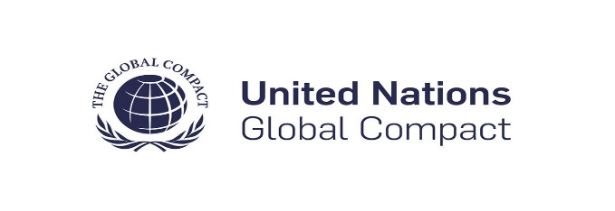

**OUR COMMITMENTS**

The UN Global Compact is a voluntary initiative to implement universal sustainability principles and to align business strategies and actions in support of achieving UN goals by 2030. The Global Compact works with entities across the UN system to uphold the Ten Principles on human rights, labor, environment, and anti-corruption into their business through strategies and policies to establish and setting the stage for people, planet, and company’s long-term success. They are also expected to annually report on their progress in implementing the principles through a Communication on Progress (COP) to demonstrate their commitment to sustainability and responsible business practices.

1. We commit to creating an inclusive and diverse workplace, free from discrimination based on race, gender, age, ethnicity, religion, sexual orientation, or any other protected characteristic.
2. We commit to upholding the rights of workers, including the right to freedom of association and collective bargaining.
3. We commit to a zero-tolerance policy regarding child labor and forced labor in all aspects of our operations.
4. We commit to a sustainable approach to our operations, reducing our environmental footprint and promoting responsible resource use.
5. We commit to transparent reporting on our environmental impact, including our carbon footprint, water usage, and other relevant metrics.
6. We commit to conducting business with integrity, honesty, and transparency.
7. We commit to providing regular anti-corruption training for our employees to ensure awareness and understanding of our commitment to combating corruption.
8. We commit to reporting on our anti-corruption efforts, including any incidents, investigations, and actions taken.

**UNITED NATION GLOBAL COMPACT COMMITMENTS**

