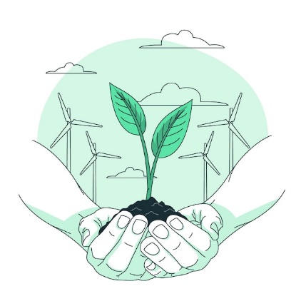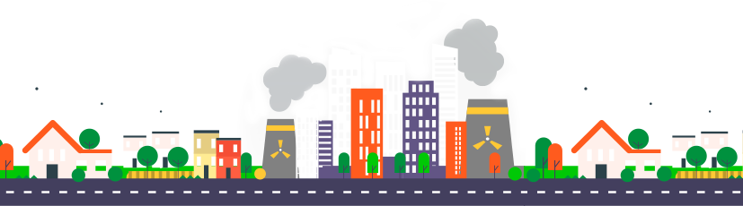 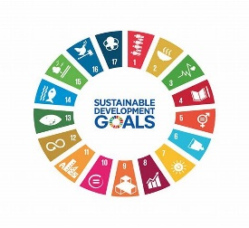

**UN SUSTAINABLE**

**DEVELOPMENT GOALS**

**OUR COMMITMENTS**

The Sustainable Development Goals (SDGs), also known as the Global Goals, were adopted by the United Nations in 2015 as a universal call to action to end poverty, protect the planet, and ensure that by 2030 all people enjoy peace and prosperity. The goals cover the three dimensions of sustainable development: economic growth, social inclusion, and environmental protection.

1. **SDG 3:** We pledge to design and maintain properties that promote the health and well-being of residents, fostering a sense of community and access to green spaces.
2. **SDG 6:** We are committed to implementing low-flow fixtures, rainwater harvesting techniques, effective wastewater management systems in our projects, treating and recycling wastewater to reduce environmental impact and promoting responsible water usage.
3. **SDG 7:** We will invest in energy-efficient technologies and renewable energy sources to provide sustainable and affordable energy solutions in our properties.
4. **SDG 8:** We commit to fair labor practices, creating job opportunities, and supporting economic growth in the regions where we operate.
5. **SDG 9:** We will invest in innovative and sustainable infrastructure, incorporating the latest technologies to minimize environmental impact.
6. **SDG 11:** We pledge to develop and manage properties that prioritize sustainable urbanization, inclusive communities, and resilient infrastructure.
7. **SDG 12:** We commit to sustainable construction practices, minimizing waste, and promoting responsible consumption throughout the life cycle of our projects.
8. **SDG 13:** We will actively work towards reducing our carbon footprint, adapting to climate change, and promoting sustainability in all aspects of our business.
9. **SDG 17:** We commit to working with stakeholders, including local communities, governments, NGOs, and other businesses, to collectively address the challenges outlined in the SDGs.